Data Structures

* A data structure is a way to store and organize data in a computer in an efficient way
* Accessing an array is easier as we can directly access any element inside the array i.e, O(1)
* Abstract Data type (ADT) define data and operations but not implementation

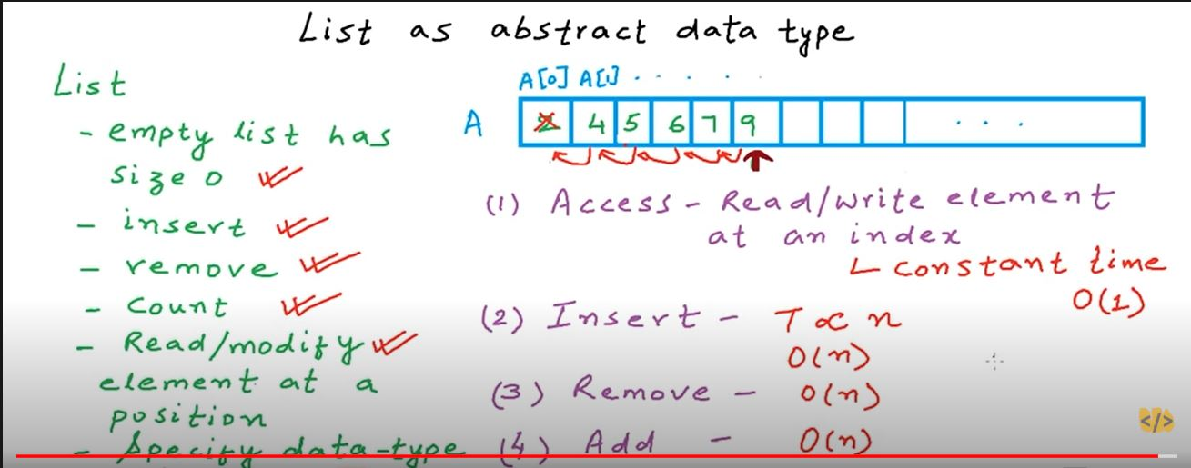

* LINKED LIST:
  + Linked list contains nodes where the beginning node has the address of the next node. Each node is a (value, address) pair. where in the last node the value is there but the address in NULL.
  + Traversing a linked list is time consuming since we only have the address of the first element of the linked list, so in order to access any element in a linked list we will have to sequentially traverse towards the element i.e, O(n).